**Project: Flashcard software system (Flashy)**

**Aim: For students to be able to create, edit and load as well as practice their flashcards to learn the topic.**

**Programming language used: Python/HTML/CSS**

**Programming platform: Visual Studio Code**

================================================================

Initially started to use python to program the starting login page for the user, this is the page shown below:

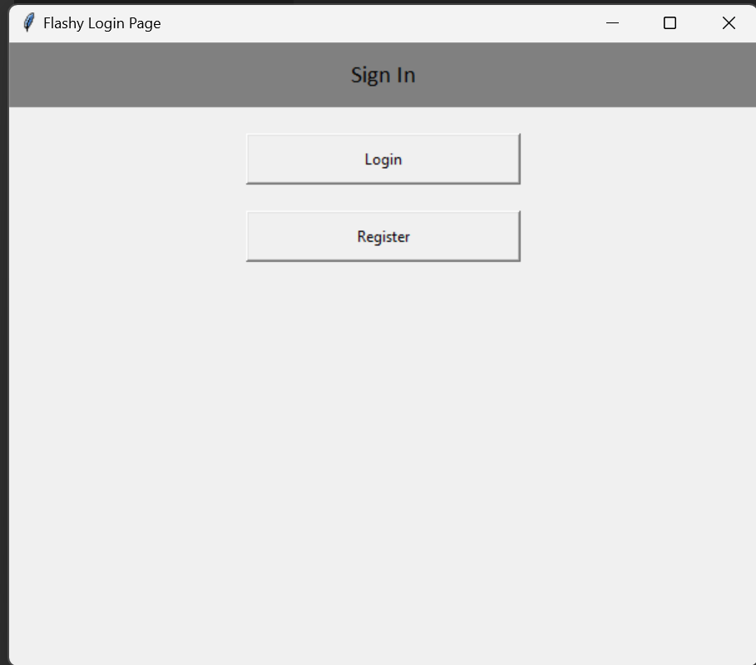This proved to be challenging as for just this window alone the code was tediously long. There was also room for a lot of bugs and errors where the program would not function according to its intent.

The register page was created afterwards and this is shown below:

This page involved the use of validation to check if the input given by the user was correct.

This was achieved by using validation in order to compare the data given by the user to the temporary database created on the system in the form of a .txt file.

Overall, this method using python seemed too long for the amount that was being created, and wasn’t also visually pleasing to look at. So I decided to try using HTML and CSS to create a website with the same functionality.

Starting to use the HTML and CSS

After learning online on the basics of HTML and using previous knowledge I started to create the initial login page that would greet users first thing. By logging in it can show different data for different users (AIM).

The login page looks like this:

This page is split into two halves, the login section as well as register section for new users. By registering their data will be stored onto database and they will be redirected to login.

This is what the register section looks like:

Each section has a form of validation where the password has to be entered in order to continue, in the registration section the email address has to be entered properly with the @ symbol.

This is the program written for the login/registration page which consists of dividing the page into two different variables, log in and register.

Style.css is the file containing the CSS code in order to control the visuals of the page.

This is the program used to define the background of the first page. The image source is from unsplash, a website specialising in wallpapers.

Below is the code for a small animation that plays if the user is to switch between “Login” or “Register”.

It is just a visual effect for aesthetics.

This is all the CSS defining the visuals of the buttons on the page, which are all centred and are comfortable to look at which was my aim.

The buttons in the HTML file are defined here, allowing them to be controlled separately throughout the program.

Link to homepage

After the login page is passed, the user is greeted with the homepage, here the goal is to have the page split into three elements which I am currently trying to program, 1) Select flashcard deck 2) Edit existing deck and 3) Create new deck.

The user can select between these three options.

Code beginning for the homepage is shown below, but I am still struggling on getting it linked to the “Log in” button on the first page.

Basic code and link to homepage CSS file “index_style.css” is complete and the UI elements for this page is what I am working on now, linking up the two pages I have discovered a bug that seems to be from clicking the “Log in” button it redirects to the same page again. I am trying to troubleshoot this but it is very difficult as I do not know what is causing it.

My attempt to link the login button is shown below.

Still trying to figure out why it is not working.

CSS for the homepage is also in progress the background and its variables have been defined:

